Supplementary Table 1 Family DA’s PGT-M results of DMD c895G>T (E299X) from mutation analysis using multiplex fluorescent PCR (F-PCR) and short tandemly repeat (STR) linked marker i.e. 5'-5n4, DXS206, DXS1236 and DXS1214 and Amelogenin X/Y and mini-sequencing for DMD c895G>T (blue>red) mutation. Trophectoderm cells were biopsied from 24 day-5 embryos of couples at risk of having DMD c895G>T offspring and went through whole genome amplification (WGA) using multiple displacement amplification (MDA). Samples from 24 embryos (Embryos DA1-DA24) were analyzed by multiplex F-PCR and mini-sequencing. Mutation analysis results were compared to karyomapping analysis

Samples/  Embryos | Father | Mother | Mother’s Mum | DA01 | DA02 | DA03 | DA04 | DA05 | DA06 | DA07 | DA08 | DA09 | DA10 | DA11
Karyomapping  analysis |  |  |  | Carrier | Carrier or Normal | Affected | Normal | Affected | Normal | Normal | Carrier or Normal | Carrier | N/A | N/A
aSNP CNV |  |  |  | 46,XX | 46,XX | 46,XY | 46,XY | 46,XY | 46,XX | 46,XY | 46,XX | 46,XX | N/A | N/A
DMD c895G>T (blue>red) | 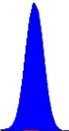 | 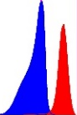 | 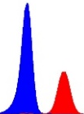 | 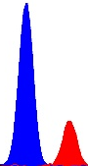 | 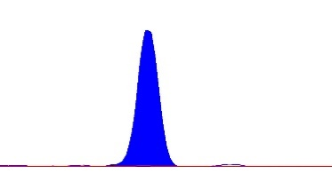 | 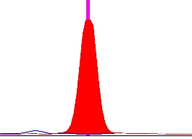 | 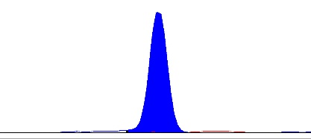  G G T G T G T G T G T G G G T G T T G T | 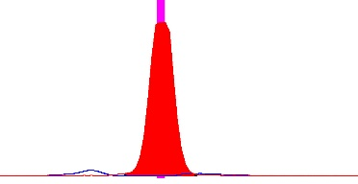 | 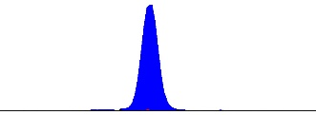 | 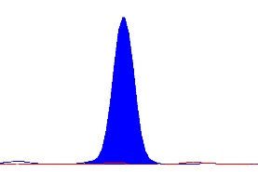 | 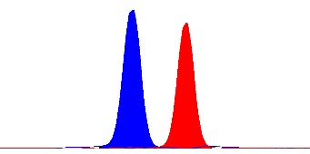 | 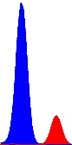 | 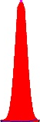 | 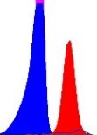
AMXY | 119X/125Y | 119X | 119X | 119X | 119X | 119X/125Y | 119X/125Y | 119X/125Y | 119X | 119X/125Y | 119X | 119X | 119X/125Y | 119X
Gender | Male | Female | Female | Female | Female | Male | Male | Male | Female | Male | Female | Female | Male | Female
Conclusion | Normal | Carrier | Carrier | Carrier | Ambiguous* | Affected | Normal | Affected | Normal | Normal | Ambiguous* | Carrier | Affected | Carrier
Samples/  Embryos | DA12 | DA13 | DA14 | DA15 | DA16 | DA17 | DA18 | DA19 | DA20 | DA21 | DA22 | DA23 | DA24
Karyomapping  analysis | N/A | N/A | N/A | N/A | N/A | N/A | N/A | N/A | N/A | N/A | N/A | N/A | N/A
aSNP CNV | N/A | N/A | N/A | N/A | N/A | N/A | N/A | N/A | N/A | N/A | N/A | N/A | N/A
DMD c895G>T (blue>red) | 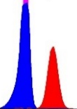 | 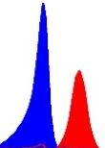 | 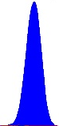 | 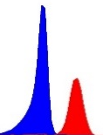 | 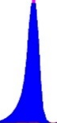 | 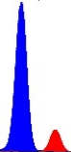 | 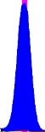 | 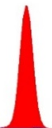  G T G T G G T G G T G T T G T G G T G | 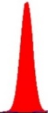 | 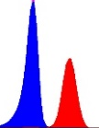 | 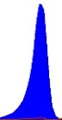 | 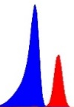 | 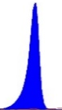
AMXY | 119X | 119X | 119X/125Y | 119X | 119X | 119X | 119X | 119X/125Y | 119X/125Y | 119X | 119X/125Y | 119X | 119X
Gender | Female | Female | Male | Female | Female | Female | Female | Male | Male | Female | Male | Female | Female
Conclusion | Carrier | Carrier | Normal | Carrier | Normal | Carrier | Normal | Affected | Affected | Carrier | Normal | Carrier | Normal

